


Blackhawk (Gift Cards) integration

Create Date: | May 14, 2024
Authored By: | Daniel Melo
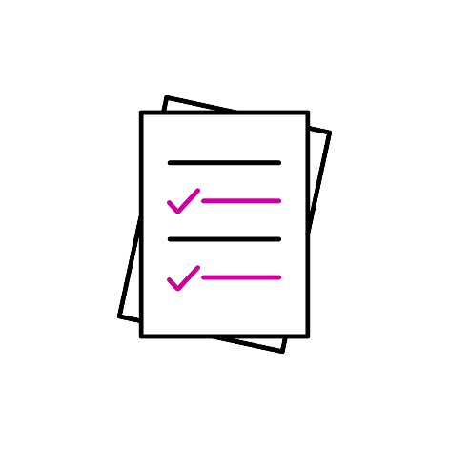
Version #: | 1.0
Last Updated: | May 14, 2024

Table of Contents
1.0 Version History 3
2.0 Gift Card Catalogue 3
2.1 Gift Cards Catalogue and Gift Cards cache 3
2.2 Gift Cards List API 6
2.3 Gift Card Details 7
3.0 Gift Card Order Placement 8
3.1 Ecommerce 9
4.0 Gift Card Order Update 11
4.1 Speedbump 11
4.2 Send order to LX 12
4.2.1 Product Not Active 13
4.3 Order fulfillment and shipment 13
4.3.1 BHN errors and auto-cancellation 14
4.3.2 Webhook events missing and polling for status updates 14
5.0 Troubleshoot and debug 16
5.1 Application Insight 16
5.2 Issue Order Stuck: recreate instance not working 16
5.3 Issue : Instance is stuck can not be recreated 18

Version History
Version | Date | Author | Summary
1.0 | May 14, 2024 | Daniel Melo | Initial Draft

Gift Card Catalogue
Gift Card orders can be placed from the Scene+ website/mobile app. Blackhawk Network (BHN) is the vendor that manages and fulfills the Gift Card orders. through APIs. The implementation of the BHN integration is within Synapze LX. Scene+ Core integrates with LX through the Synapze LX SDK. The SDK is available as a NuGet package, but due to the lack of access from the pipeline agents in the Scene+ project, the .dll has been taken from the NuGet package and imported manually to the Scene+ Core solution.

Gift Cards Catalogue and Gift Cards cache
The integration includes the catalogue of Gift Cards available for redemption. The catalogue is maintained by BHN, with a copy maintained on Synapze LX, and another at the Content Management tool Agility. The LX coy is cached by Scene+ Core on Redis.
Catalogue updates are usually not frequent. Whenever a catalogue update is required, BHN has to update first, then LX runs a catalogue sync and updates their copy, and finally Scene+ Core cache is set to refresh every night at 5am UTC (12am to 1am ET).
Referring to the enhancements described in the following FSD can help understanding these mappings: Gift Card Enhancements FSD
The Cache Refresh method is a Timer Trigger function called RefreshGiftCardsCache at the Content function app.
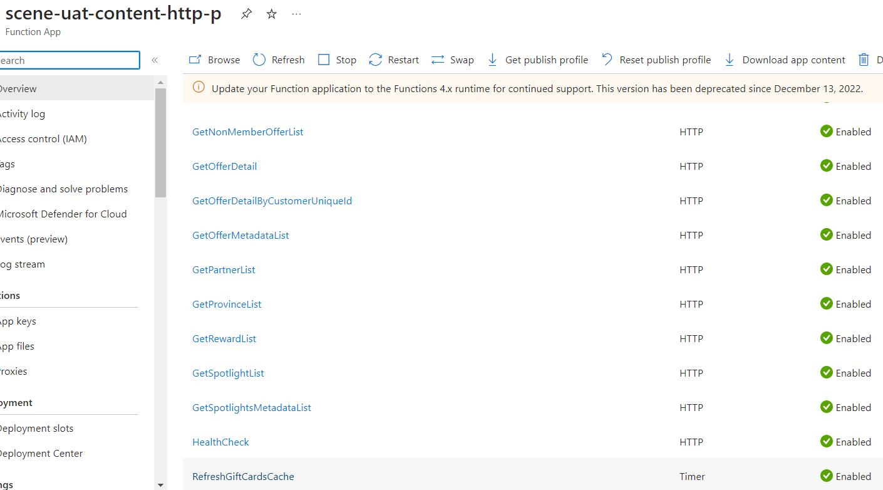

The function implementation can be found in the FunctionApps.Content.HTTP project, GiftcardFunctions.cs file.
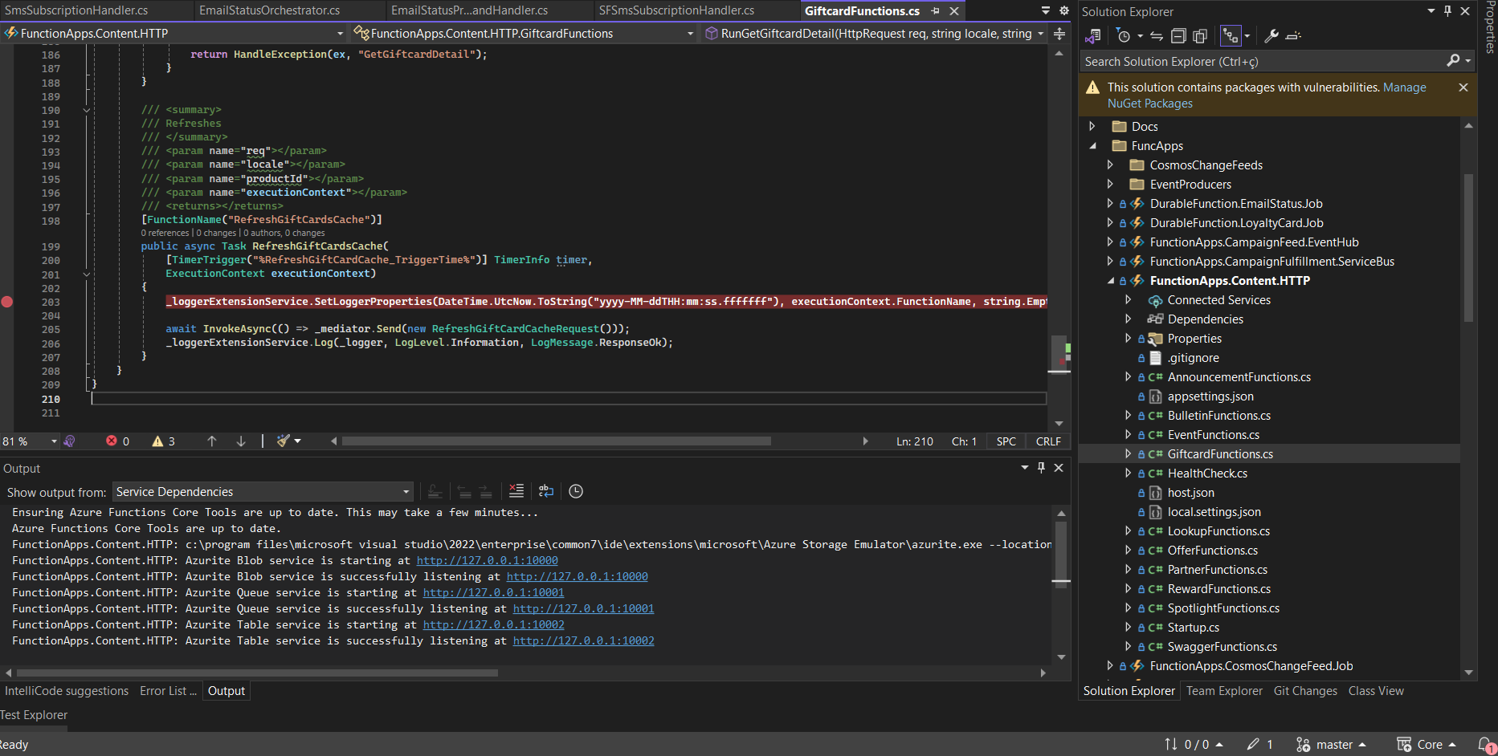

This function calls three methods from the Synapze LX SDK, being one to get the list of active products in the Gift Cards catalogue, one to get all the variants of a product (denominations), and one to get the product details for each and all of them.
These products are then grouped by BrandID, which is a brand identifier in the object returned. This BrandID is known by BHN as Product Line ID. The response is grouped because the same brand can leverage multiple Gift Card denominations, which means the same brand contains Gift Cards for multiple dollar values and one point denomination for each value. Each denomination will have its own Product ID on LX, but will be worked in the same Brand page on the website/mobile app. The Product separation for Blackhawk is given by the UPC field, which maps to the LX ExternalSku field.
Secondarily, the products within a given Brand ID context are grouped again by Type, which is the Digital and Physical designation. BHN is able to fulfill orders for both Physical and Digital Gift Cards, and Scene+ leverages these options to the members. Physical Gift Cards are shipped to the member’s shipping address, and Digital Gift Cards are fulfilled, the URL generated and sent by email to the Scene+ member.
Lastly, the Gift Cards are grouped by ExternalSku. This grouping is obsolete and used to allow only one product per ExternalSku, to prevent duplicate denominations from appearing in the Website. Even though the grouping still happens, currently, all products under the ExternalSku are listed in the denominations on the Website.
This operation is locale based and executed once for English, once for French. These locales are in the configuration below:

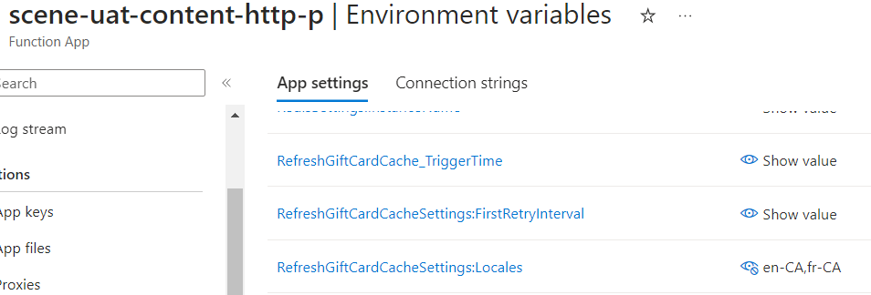

The grouped response is then saved in the Redis cache under one key for each locale (not each Product or each Brand ID), being LxGiftCardCatalog_{locale}.
The Refresh Gift Cards cache method has a custom retry implementation using Polly, controlled by the configurations below. The Trigger Time of the function is also configurable.

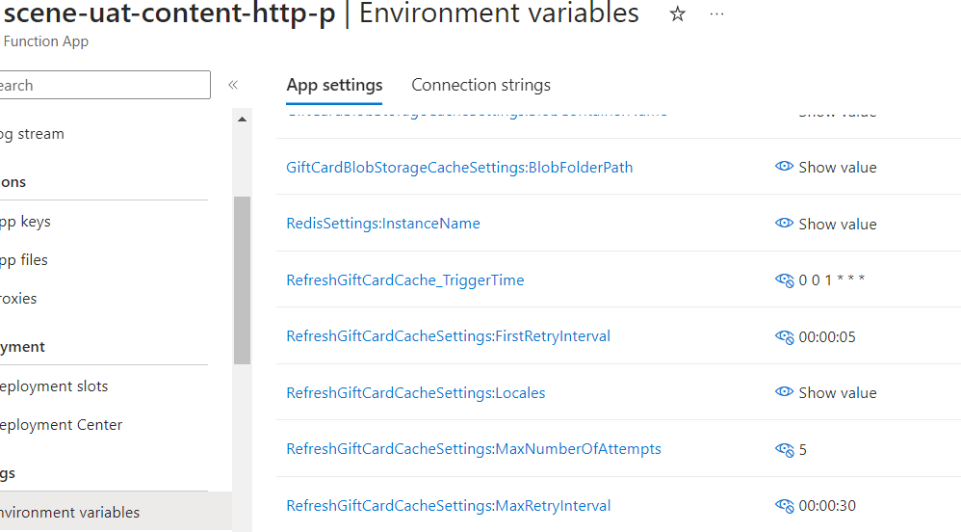

Sometimes, as an exception scenario, the Gift Cards catalogue cache has to be refreshed adhoc. For this, the same Refresh function in the Content Function App is leveraged. It’s called from the Code + Test menu.
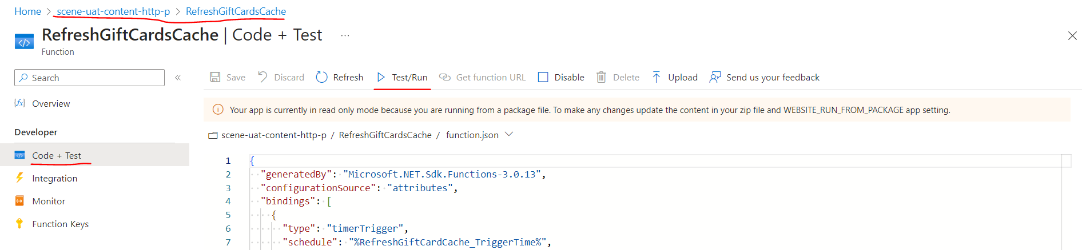
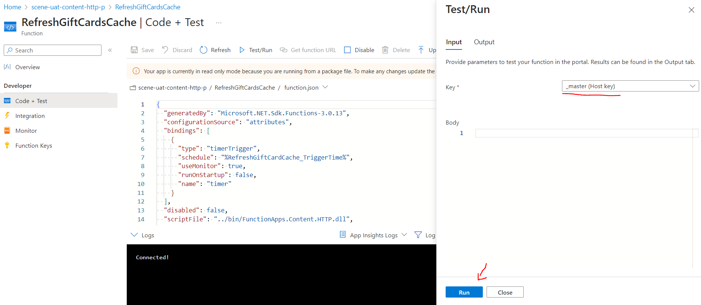

Blackhawk doesn’t work with points directly. They send the dollar values of the Gift Cards available. However, the setup of the points denomination for each dollar amount is done by LX. Scene+ Core consumes this mapping from LX and receives the products with both dollar amount and points value set. The denominations setup is done through business processes.

Gift Cards List API
An endpoint is exposed through the Content API for the Website to fetch the list of Gift Card brands available. This method not only uses the cached catalogue (if there’s nothing in the cache, the method returns an error), but also the Agility catalogue. The Agility catalogue is maintained by Scene through business processes.
The Agility catalogue maps to the Brand ID of the cached catalogue items and contains some additional metadata, like the category of that Gift Card brand, as well as works as a “control” type of catalogue.
The endpoint to fetch Gift Cards list is implemented in the Content Function App.

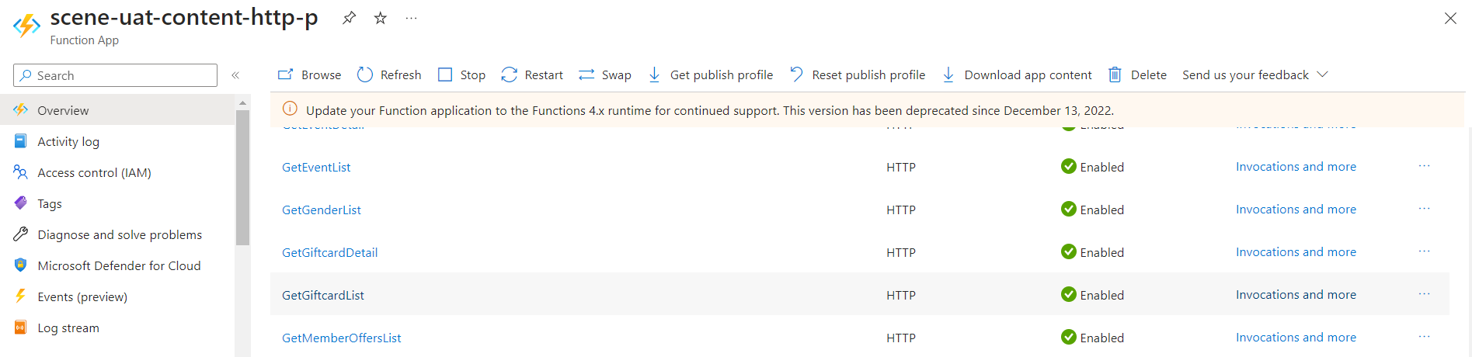

The implementation can be found in the FunctionApps.Content.HTTP project, GiftcardFunctions.cs file.
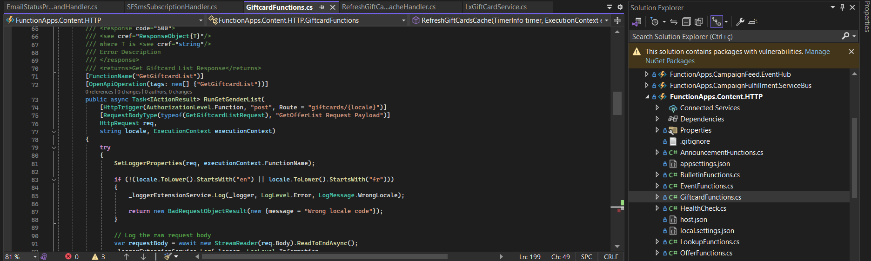

This method fetches the cached catalogue and Agility catalogue and match them. Only the brands that appear on both catalogues are returned. If a brand is unpublished in Agility, it will no longer be returned by the endpoint, and therefore will stop appearing on the Website final catalogue.
The response of the API is then used to display the brands in the Website Rewards page.

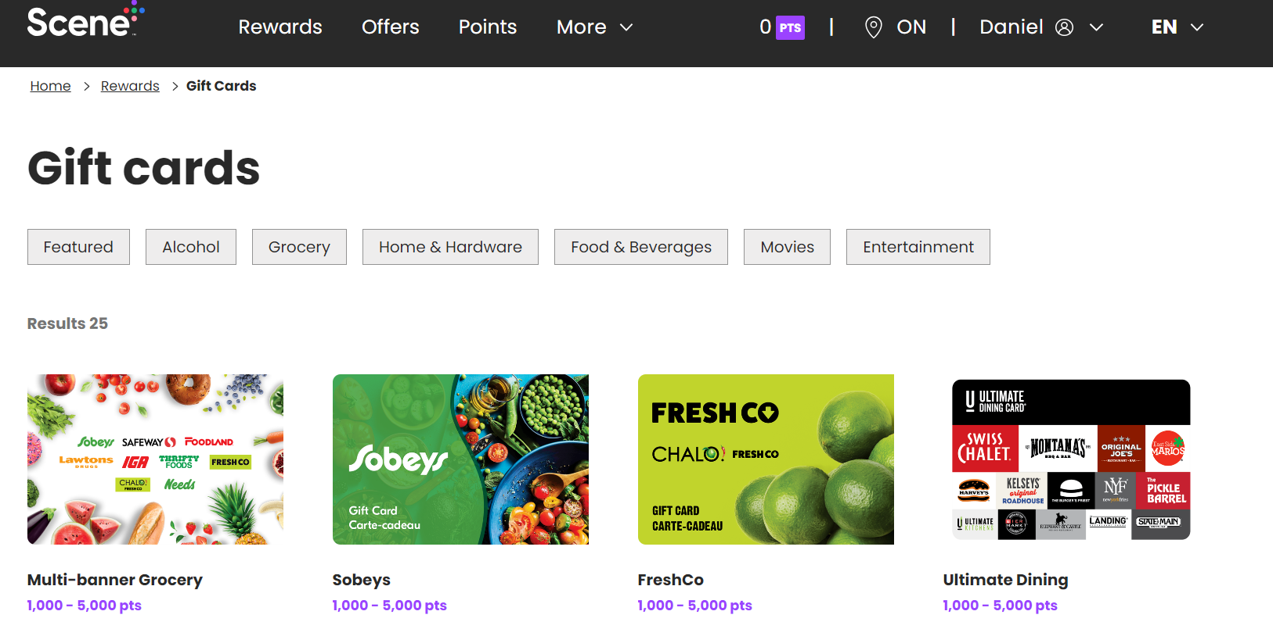

Gift Card Details
A final catalogue method is provided in the Content function app.
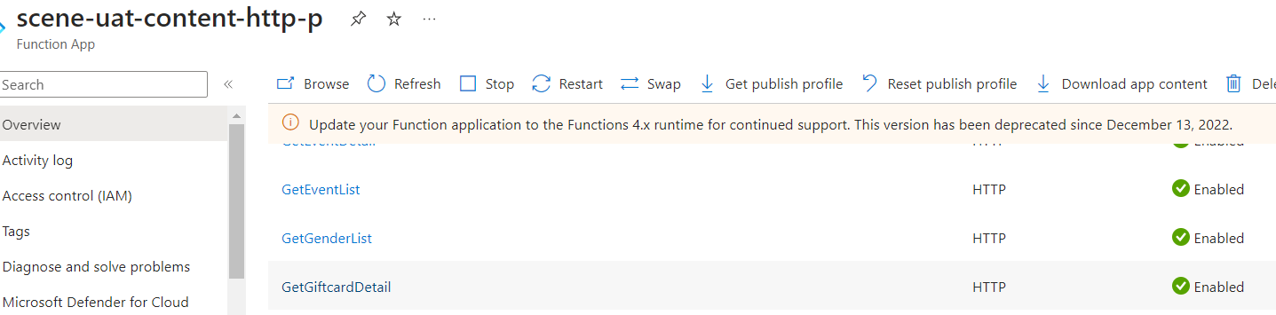

This endpoint is exposed through the Content API, and the implementation can be found in the FunctionApps.Content.HTTP project, GiftcardFunctions.cs file

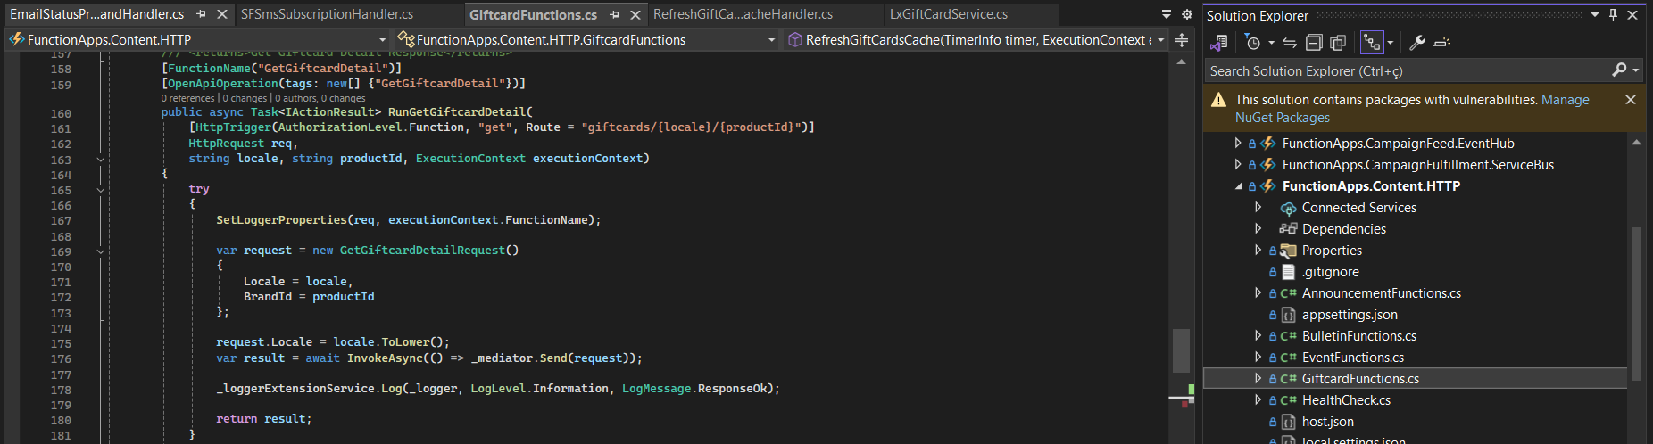

This endpoint is used to list all the products under a given Brand ID, separated by Type. This is then displayed on the Website Brand page.

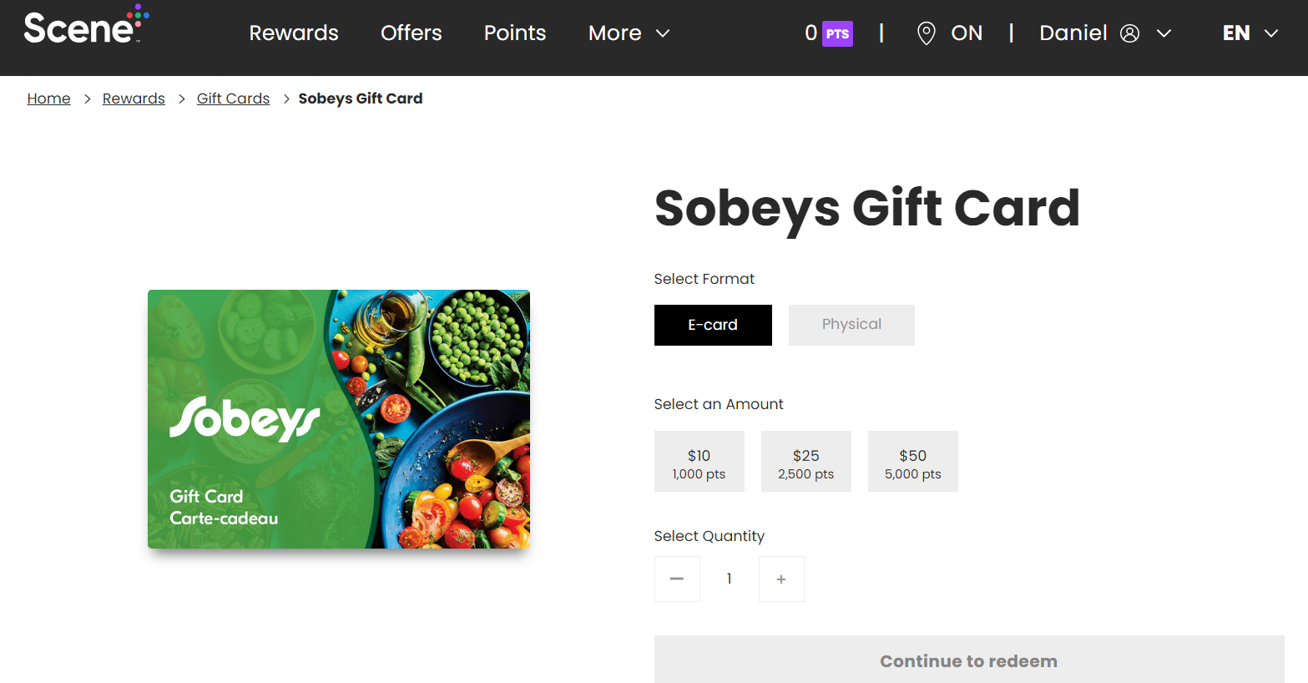

Gift Card Order Placement
Different from other partners, Gift Card orders are placed entirely from Scene+ website. No shopping cart is provided during this operation, which means only one product can be selected in a Gift Card order. Multiple line items for the same product are allowed (configurable, currently only allowing 1 per order).
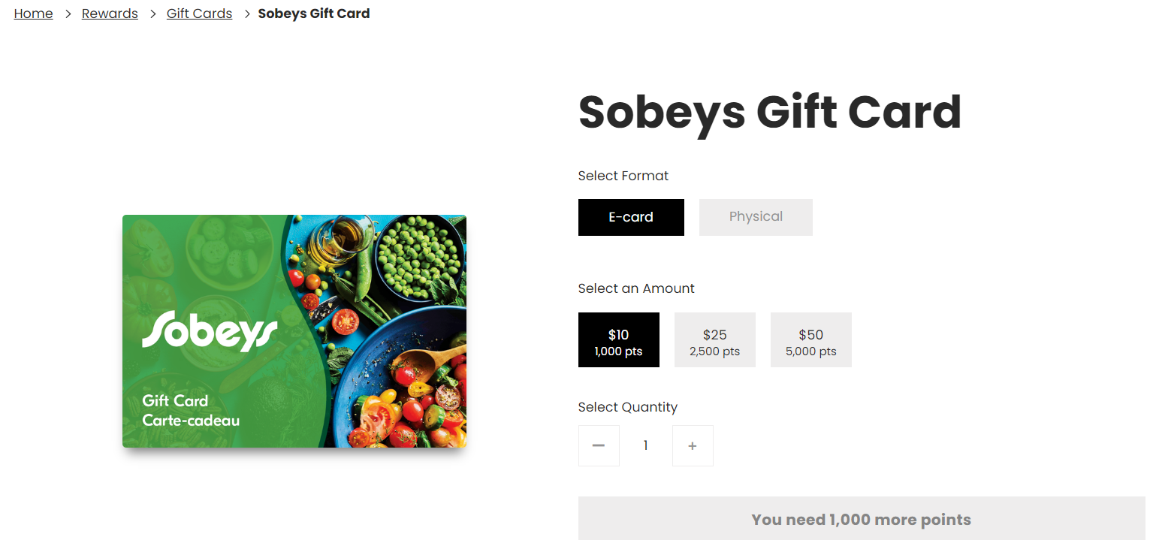

Ecommerce
Once the member finishes selecting the product, the quantity and the Shipping Address, a request is sent to the endpoint to create Gift Card orders. This endpoint is exposed in the Ecommerce API.
The function is implemented in the Ecommerce Function App.

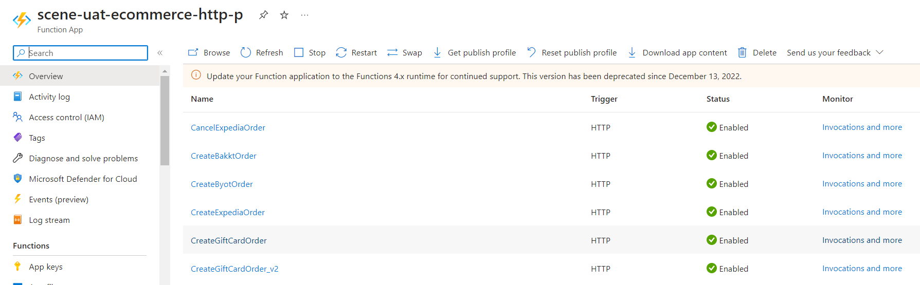

The v2 endpoint works with an MFA token to further validate the member doing the redemption as part of the mandatory MFA flow from Website and App.
The implementation can be found in the FunctionApps.Ecommerce.HTTP project, GiftCardOrder.cs file.
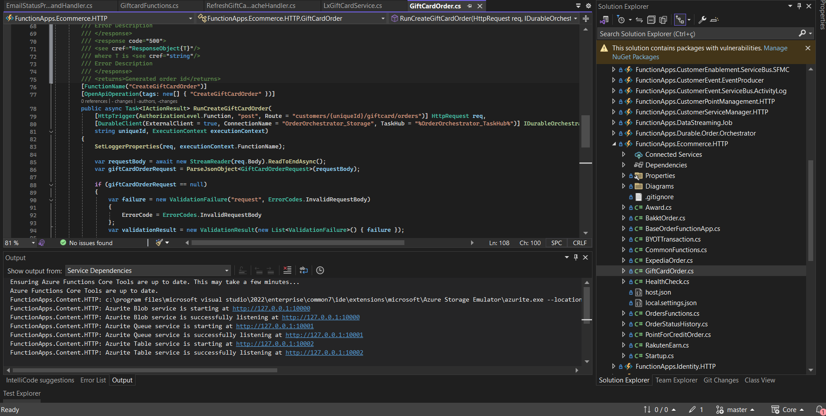

Once the request is received and validated, the function:

- Creates the SQL records on Core.OrderDetailTracking and Audit.OrderDetailTrackingHistory
  - The records are created with the PENDING status
  - One record is created for each line item (five records are created for an order with a selected quantity of 5)
- Creates the Cosmos order and point document, as well as the point liability reconciliation
  - Customer Balance is updated in real time together with the creation of these documents
- Pushes a message to the Liability Reconciliation Service Bus queue
  - Account balance updates and liability burn are executed by the liability reconciliation job
- A new instance of the Gift Card Orchestrator durable function is started. One instance is started per order (not per line item), and the instance ID is the Order ID (the “id” field in the Cosmos document and the OrderID field on SQL).
As part of the request validation, certain configurable limits are checked. These limits are for:

- Quantity of Gift Cards allowed per order
- Quantity of Gift Cards a member can redeem per day
- Number of Gift Card orders a member can place per day
- Amount of points a member can spend on Gift Card orders per day

These limits are in the configurations below:
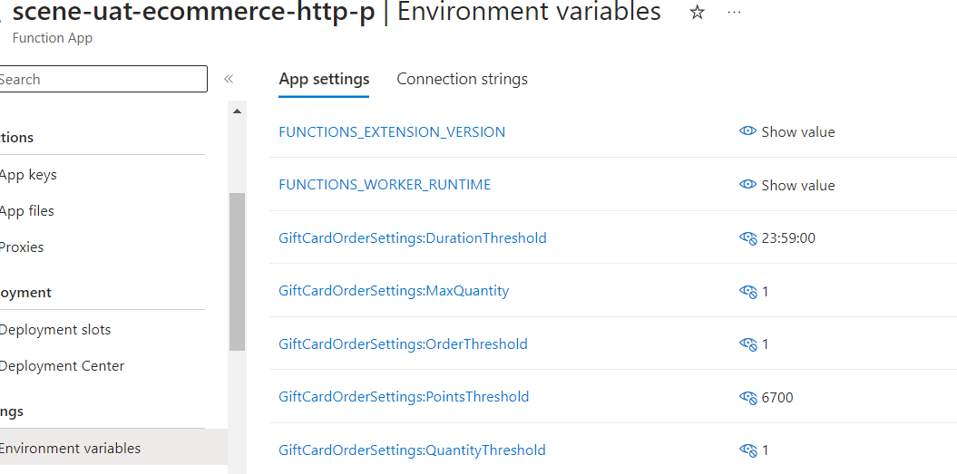

The Quantity Threshold, Order Threshold and Points Threshold are validated in a rolling window with the duration of the Duration Threshold.
The current values in production are 1 GC per order, 1 GC per day, 1 order per day, 5000 points per day.
The original FSD for the implementation of this and a few other Gift Card enhancements can be found here: Gift Card Enhancements FSD

Gift Card Order Update
The Gift Card order updates are managed by the Gift Card Order Orchestrator, the Durable Function Orchestration implemented in the Orchestrator Function App. This Function App is currently entirely dedicated to the Gift Card orders orchestration.
One orchestration instance is created for each Gift Card order. This orchestration instance is responsible for managing the entire lifetime of that specific order.
The implementation is in the “ochestrations” function app (with a typo in the name).

Speedbump
The first operation executed by the orchestration instance a “wait” operation. The speedbump is a timer for the order to be stopped in the PENDING status. As part of the regular data streaming jobs, orders are streamed to BNS. The speedbump time is used by them to manually investigate for Gift Card orders fraud. During the speedbump time, if an order is flagged as a potential fraud, it can be Suspended. This can be done from the Order History on CSM. Once Suspended, the order remains Suspended until explicitly Unsuspended (Released). This gives more time to action over the order.
The current speedbump time is 48h and is controlled by the configuration below, in the format D.HH:mm:ss.
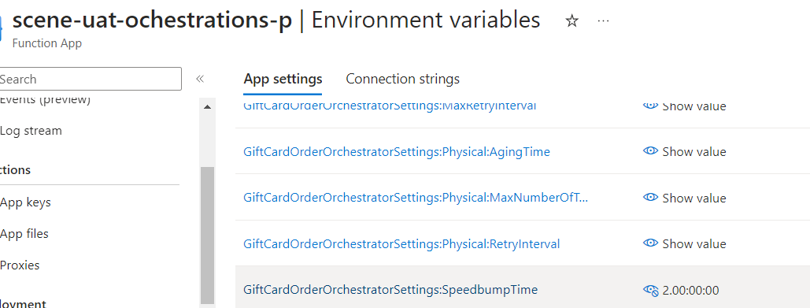

Suspension does not pause the speedbump. This means that if an order is immediately suspended, and then released after 48h, it will not wait for 48h more.
However, while suspended, the order will also not move, so if an order is immediately suspended, after 96h it will still be suspended. If released, it will not wait for 48h more. This is achieved by forcing the Orchestration instance to wait for an unsuspension event after the speedbump timer elapses and the order is suspended. The Data Streaming structure is then leveraged to notify the orchestration instance that an order has been unsuspended. A subscription exists for Order Unsuspension events in the Customer Event topic on Service Bus, and a Service Bus Trigger function in the Orchestrator Function App reads this queue and signals to the Orchestration instance that the order has been unsuspended.
If an order is immediately suspended and released after 10h, then the order will stay in the pending status waiting for 38h more. No further events are required for this scenario, as the speedbump timer will keep counting throughout the entire operation.

Send order to LX
Scene+ Core does not integrate directly with Blackhawk. Instead, after the 48h are elapsed, the order is pushed to LX. For this, a sequence of methods are called from the LX SDK to Create the order in the platform.

- Try to fetch the Member from LX using the External Member Identity
  - If not found
    - Create the member with minimalistic data on LX
    - Create the External Member Identity entity on LX with the Scene+ Customer GUID
    - Create the member account, if not automatically available
- Fetch the currency type from LX. For Gift Card orders, it will always be “points”
- Create the order on LX, passing the member’s name, shipping address and line items details
  - The Scene+ Order ID is passed in the metadata object of the LX order with the key ExternalOrderId
- Execute a transaction on LX to inject dummy points in the member’s account balance. LX does not hold Scene+ balances, they are managed by the Scene+ implementation on Cosmos. This step is required to get the order status to move on LX.
- Pay for the LX order using the dummy points added to the LX balance.

After the order is successfully created and paid for on LX, the Scene+ OrderDetailTracking record is updated with the order status changed to INPROGRESS and the SourceOrderId holding the LX order number. This number is shared with LX whenever investigation support is required. The orchestration instance then awaits order update events.
This operation is, nowadays, the major reason for orders to get “stuck” in the PENDING status. This happens because sometimes the HTTP calls to LX fail, or accuse a failure, triggering a retry for an operation that already happened. We often see the message “Order status invalid for payment.” This happens because the payment step was successful, but returned error (potentially timeout), and then was tried again. Whenever an order is “stuck” because of any errors related to calling these methods, they are just reprocessed. A Gift Card order reprocessing KT session will be provided by Nikhil. The supporting document written by Nikhil is available at the Knowledge Base folder and through the following link: Gift Card reprocess transition document

Product Not Active

As part of the Gift Card enhancements shared above, an automated cancellation of Gift Card orders that receive the error “Product is not active” from LX was implemented. This error means that between the order placement and the order being sent to LX, the product is no longer in the catalogue. There is no way to solve or bypass this validation, and the order is now automatically cancelled and refunded. All line items in the order have their status changed to CANCELLED and an Adjustment point document is created to refund the points for the total points value of the order. CANCELLED is a final status will not be further updated by regular means.

Order fulfillment and shipment
The Fulfillment and Shipment terminology is used to determine what is done by BHN to deliver the Gift Cards in an order. A digital Gift Card is fulfilled, while a physical Gift Card is shipped. The status of Gift Card orders fulfilled and shipped on LX and on Scene+ Core is the same: SHIPPED. SHIPPED is a final status and will not be further updated by regular means.
For the sake of simplicity, the fulfillment term will be applied to both Physical and Digital.
BHN fulfills a Gift Card order and LX gets the updates through their Azure Logic Apps that deal with the Blackhawk integration. This fulfillment can be partial for digital Gift Cards, meaning the fulfillment can happen by line item, but will always be for the entire order for physical Gift Cards. Whenever LX receives the updated status of the line items, they fire a Webhook event containing the entire LX order object with the “shipped” status for the relevant line items.
Scene+ Core has a Webhook listener HTTP Trigger function in the Internal function app.

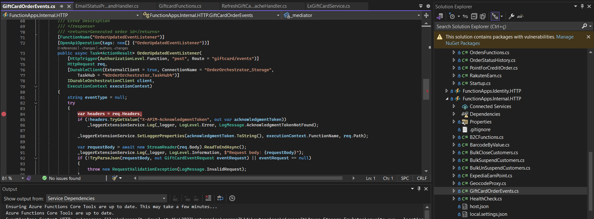

This webhook listener is responsible for checking if the event type incoming is “order.updated”, and then forward the event to the orchestration instance. Whenever this method is able to read an event from LX, it returns a successful response, regardless of the result of forwarding the event to the orchestrator.
Once the orchestration instance receives an order updated event, it:
- Fetches the entire LX order object within the event payload
- Iterates through the line items
  - For each line item with status shipped
    - Updates the corresponding records status on the Core.OrderDetailTracking table to SHIPPED.
    - Populates the additional fields depending on Gift Card type
  - For each line item with status cancelled (see section 4.3.1)
    - Updates the corresponding records status on the Core.OrderDetailTracking table to CANCELLED
    - Creates an Adjustment point document to refund the points amount of that line item

Additional fields are populated once a line item status is changed to SHIPPED. For digital Gift Cards, the Gift Card Barcode, URL and PIN are saved in the OrderDetailTracking table. For physical Gift Cards, the Carrier, Tracking Number and Shipment Date are saved in the OrderDetailTracking table.
Once all line items in an order are either SHIPPED or CANCELLED, the orchestration instance finishes.

BHN errors and auto-cancellation

As part of the implementation of automated cancellation of Gift Card orders, LX detected errors coming from Blackhawk for which the recommended solution was to cancel the orders. LX then started sending order.updated events with the line item status “cancelled” when these errors are received. Digital Gift Card orders can be partially cancelled (a set of line items will have the status update), while for Physical Gift Card orders, all line items will be cancelled at once.
The same order.updated event is pushed to the Webhook, and therefore the event type is expected by the Webhook listener and forwarded to the orchestration instance. Once the orchestration instance receives an event with cancelled items, the cancellation is handled as described above while the orchestrator iterates through the LX order object line items.

Webhook events missing and polling for status updates

In the past, orders would get “stuck” in the INPROGRESS status because a webhook event went missing. To mitigate this, an additional implementation was made to fetch the LX order object periodically, for a given amount of tries, after an order is deemed “aged”. The number of tries, time between calls and Aging waiting time are configurable and are configured separately for Physical and Digital Gift Card orders.
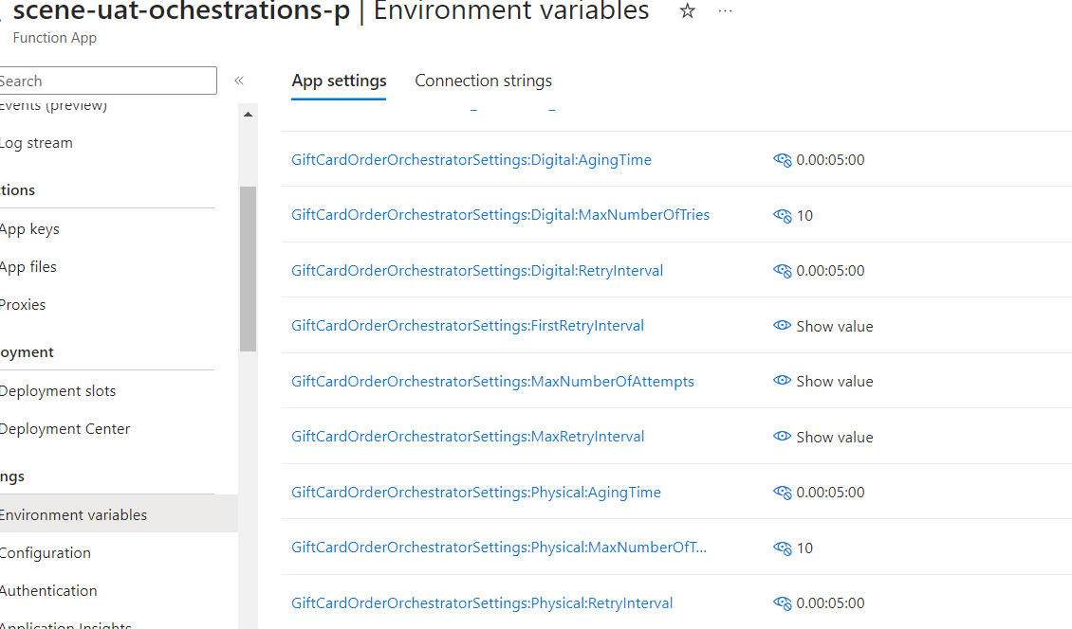

In production, these are configured to deem the order aged after 24h, and then call LX to fetch the object once a day, up to 21 days.
This order object is then used to update the line items status applying the exact same logic as if the object was received from the Webhook.

Troubleshoot and debug.
Here some helpful tips to investigate and debug issues,
link : how to use Adhoc functions for reprocess of orders: Gift Card reprocess transition document

Application Insight
Order orchestrator: sceneplus-prod-ochestrations-p
Order orchestrator app insight name: sceneplus-prod-funcapps-http-appinsights

Adhoc function app: sceneplus-prod-adhoc-http
Adhoc function application Insight : sceneplus-prod-funcapps-http-appinsights

Issue Order Stuck: recreate instance not working

How to view application Insight for Order Orchestrator and Adhoc function app to fix stuck orders.
Follow provided document link to recreate instance using adhoc process if order is stuck in pending status
If it continue to fail most likely issue is product in order is not available.

To debug issue check error on adhoc function app.. if it is failing on

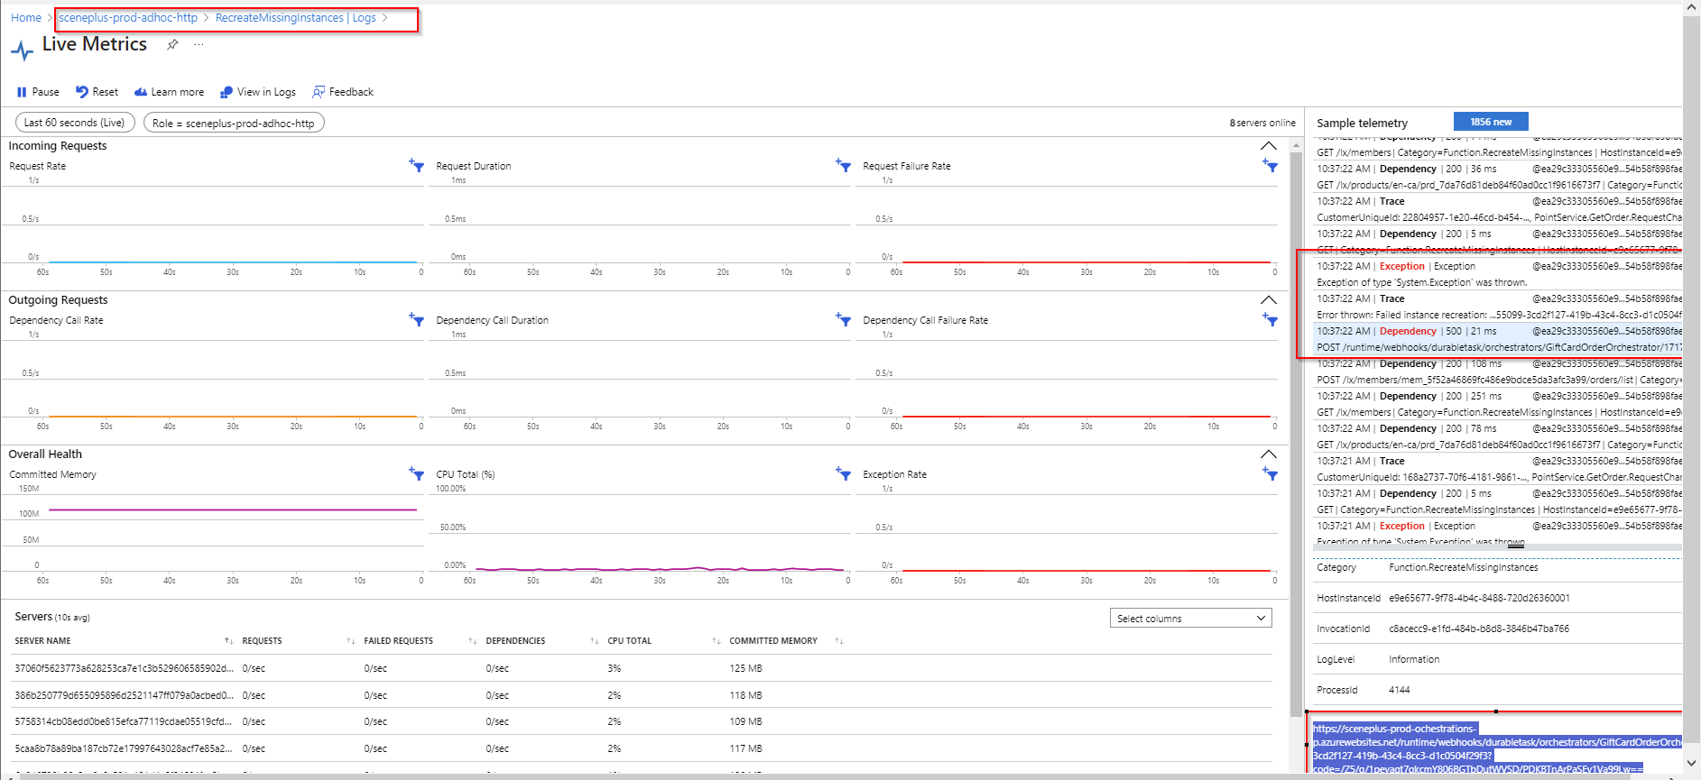

If error is related to order orchestration look into related application insight

Use Transaction search by Order Id ie (1717096919-2076639e-c319-466f-886d-2a85ab64fab1)
Look for exceptions and error detail.
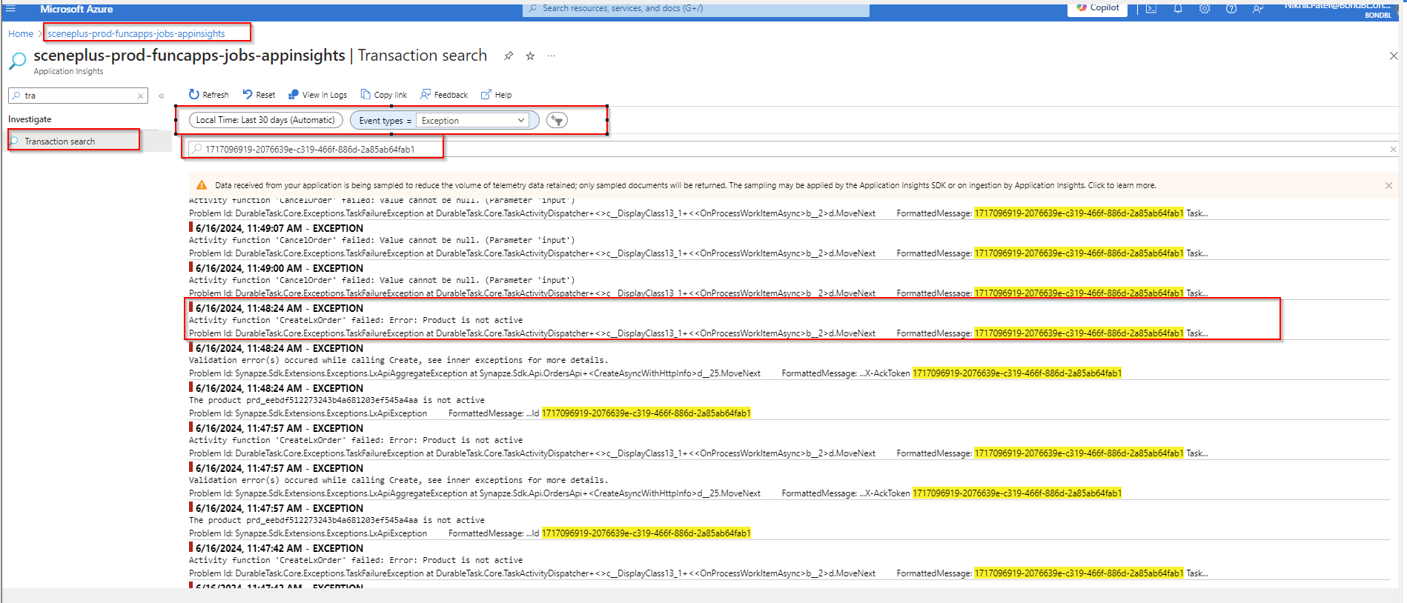
Order stuck into pending status

If error is related to Product is not active as provided bellow example, check it with LX team member, as product will not be active and inform ITOps team to cancel order and refund points to user.

6/16, 11:48:24 AM - EXCEPTION
Activity function 'CreateLxOrder' failed: Error: Product is not active

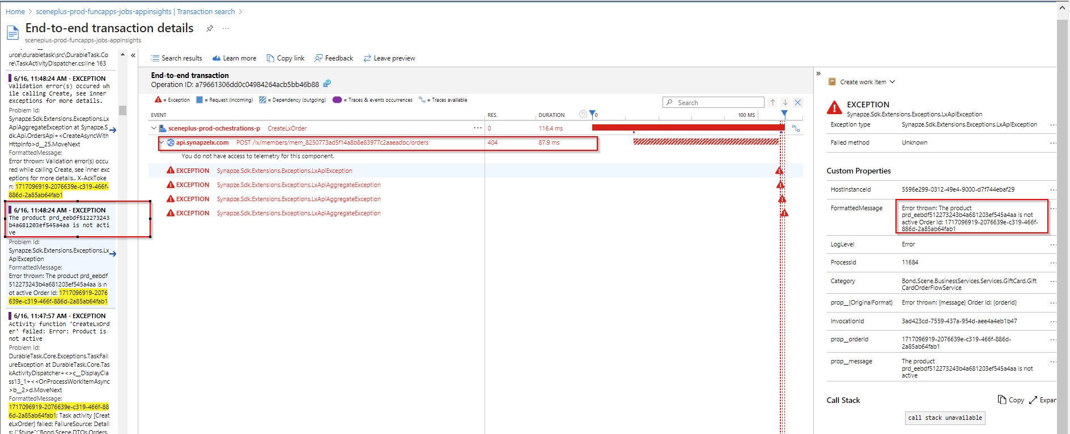

Other common error observed:
Error thrown: The activity function 'CancelOrder' failed: "Value cannot be null. (Parameter 'input')". See the function execution logs for additional details.. X-AckToken: 1717096919-2076639e-c319-466f-886d-2a85ab64fab1

In this case need to calla adhoc function to Recreate Instance, check related documentation.

Issue : Instance is stuck can not be recreated
An Orchestration instance with the status Running already exists

If issue is related “instance is already running”, then it can further investigate by looking into web storage account , table

Eror detail :
"StackTrace": " at DurableTask.AzureStorage.AzureStorageOrchestrationService.CreateTaskOrchestrationAsync(TaskMessage creationMessage, OrchestrationStatus[] dedupeStatuses) in C:\\source\\durabletask\\src\\DurableTask.AzureStorage\\AzureStorageOrchestrationService.cs:line 1558\r\n at DurableTask.Core.TaskHubClient.InternalCreateOrchestrationInstanceWithRaisedEventAsync(String orchestrationName, String orchestrationVersion, String orchestrationInstanceId, Object orchestrationInput, IDictionary`2 orchestrationTags, OrchestrationStatus[] dedupeStatuses, String eventName, Object eventData, Nullable`1 startAt) in C:\\source\\durabletask\\src\\DurableTask.Core\\TaskHubClient.cs:line 614\r\n at Microsoft.Azure.WebJobs.Extensions.DurableTask.DurableClient.Microsoft.Azure.WebJobs.Extensions.DurableTask.IDurableOrchestrationClient.StartNewAsync[T](String orchestratorFunctionName, String instanceId, T input) in D:\\a\\r1\\a\\azure-functions-durable-extension\\src\\WebJobs.Extensions.DurableTask\\ContextImplementations\\DurableClient.cs:line 170\r\n at Microsoft.Azure.WebJobs.Extensions.DurableTask.HttpApiHandler.HandleStartOrchestratorRequestAsync(HttpRequestMessage request, String functionName, String instanceId) in D:\\a\\r1\\a\\azure-functions-durable-extension\\src\\WebJobs.Extensions.DurableTask\\HttpApiHandler.cs:line 792\r\n at Microsoft.Azure.WebJobs.Extensions.DurableTask.HttpApiHandler.HandleRequestAsync(HttpRequestMessage request) in D:\\a\\r1\\a\\azure-functions-durable-extension\\src\\WebJobs.Extensions.DurableTask\\HttpApiHandler.cs:line 296"
Postman example :
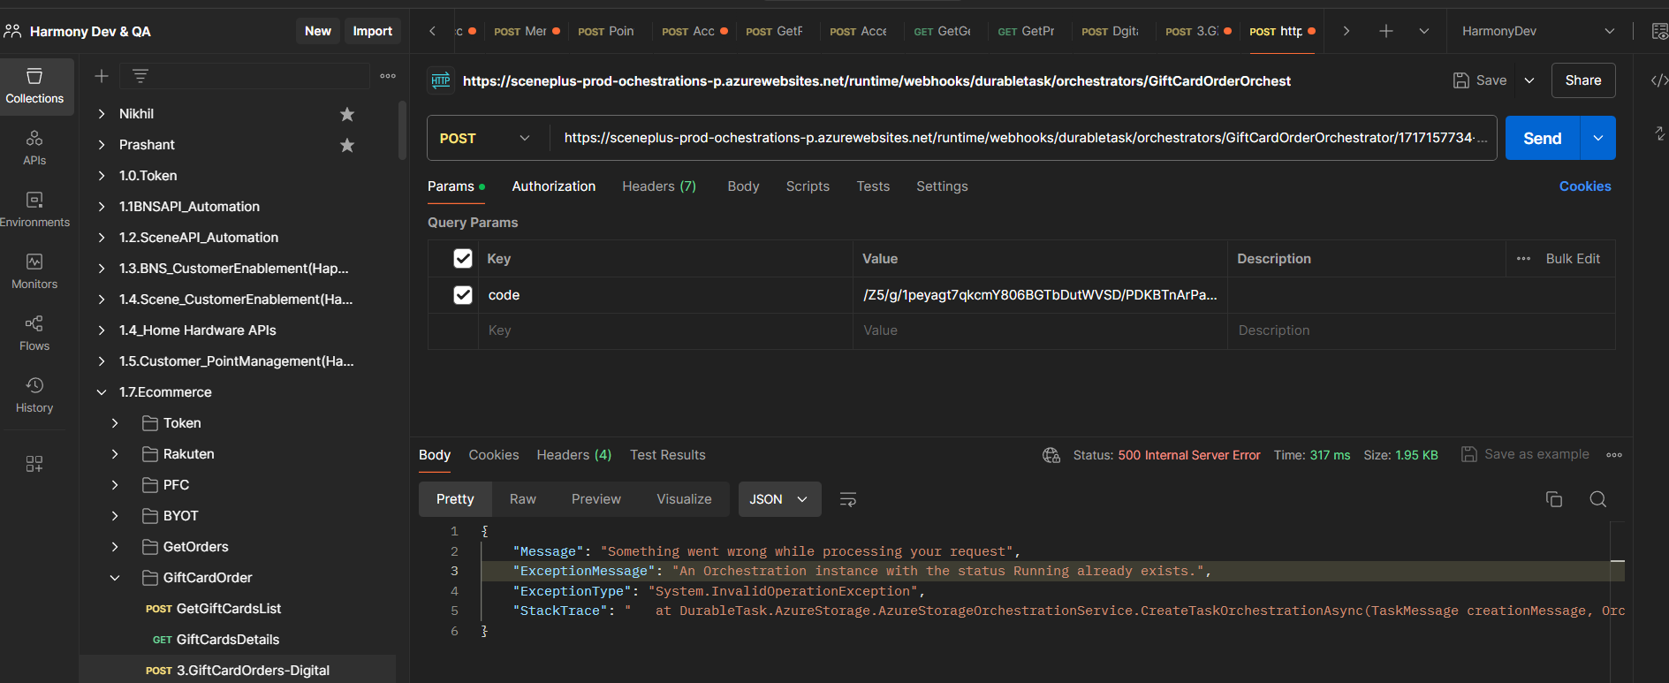

For Production need to look into key valut and find appropriate storage account and table using key vault and look for active instance into table as this example …
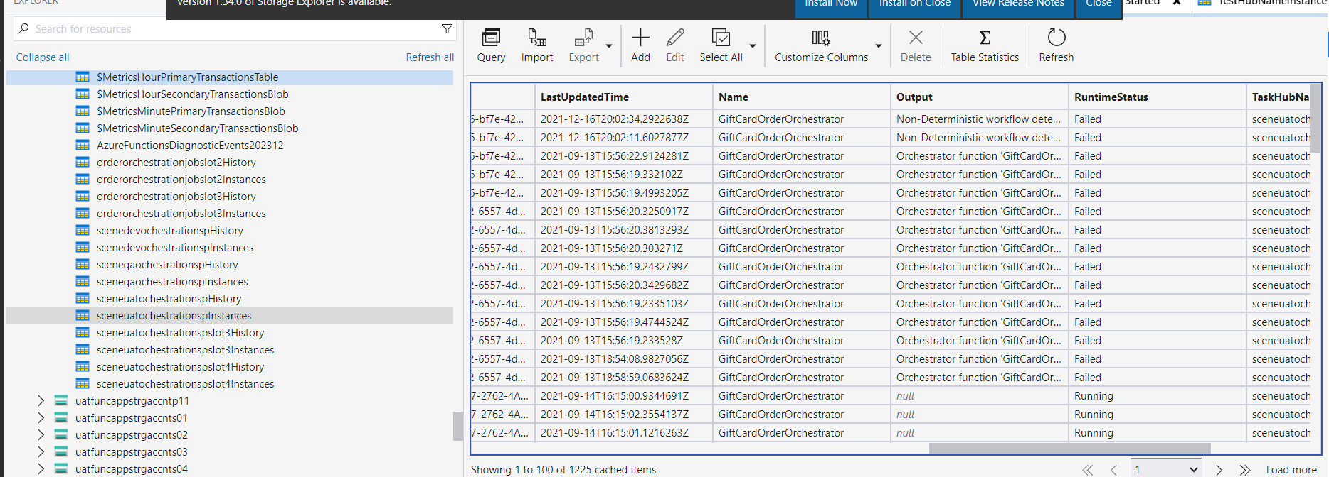

Detail:
{"ClassName":"System.NullReferenceException","Message":"Object reference not set to an instance of an object.","Data":null,"InnerException":null,"HelpURL":null,"StackTraceString":" at FunctionApps.Durable.Order.Orchestrator.GiftCardOrderOrchestrator.SendOrderToLx(IDurableOrchestrationContext context, GiftCardOrchestratorRequest request, RetryOptions retryOptions) in D:\\a\\1\\s\\src\\SceneBackend\\FunctionApps.Durable.Order.Orchestrator\\GiftCardOrderOrchestrator.cs:line 116\r\n at FunctionApps.Durable.Order.Orchestrator.GiftCardOrderOrchestrator.RunGiftCardOrderOrchestrator(IDurableOrchestrationContext context) in D:\\a\\1\\s\\src\\SceneBackend\\FunctionApps.Durable.Order.Orchestrator\\GiftCardOrderOrchestrator.cs:line 78","RemoteStackTraceString":null,"RemoteStackIndex":0,"ExceptionMethod":null,"HResult":-2147467261,"Source":"FunctionApps.Durable.Order.Orchestrator","WatsonBuckets":null}

